****Important Note: The Phases of the moon diagram that you copied down in class may be wrong, so go with the information below. The phase’s start from the New Moon must go counter clockwise (no mater which side the sun is on)

Phases of the moon (be able to draw in order)

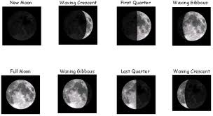
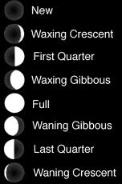

Notice Below: No matter which side the sun, phases go counter clockwise, starting at New Moon

